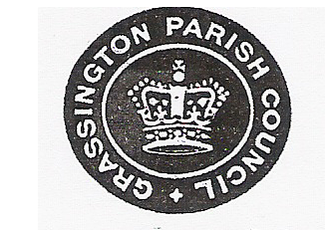
GRASSINGTON PARISH COUNCIL
Minutes of the Annual Parish Meeting held in The Jackson Room of the Devonshire Institute
Monday 9th May 2019 at 6.30pm

Chairman’s Remarks
The Chairman, Councillor Charlton chaired the Annual meeting of the Parish and welcomed everybody to the meeting and thanked them for their attendance.

Apologies for Absence
Apologies were given by Councillor Egan who was absent due to holiday.

To Approve the minutes of the 2019 Annual Parish Meeting
Proposed by Councillor Lofthouse
Seconded by Councillor Smith
Resolved to accept the minutes of 2019 Annual Parish Meeting

Chairman’s Report
The Chairman gave his report, copy attached

Parishioner’s Forum
No questions raised

With no other business to discuss the meeting closed at 6.38pm

